Karnataka Elections (100 Marks)

In the recent Karnataka Assembly elections, BJP and Congress have emerged as the two largest parties. BJP fell short of few seats, and could not make government in spite of having overwhelming public support. This is the beauty of politics, where winners may become losers and losers may become winners.

The Think-Tank of BJP has gathered in New Delhi to discuss the possible causes of their failure. For the brain-storming a large map of Karnataka has been brought which contains details of the various constituencies and the winning party for those constituencies. The map contains only details about the constituencies in which either BJP or Congress won. Each constituency is described by a point in the  2D plane.

The senior leadership of BJP has insisted on identifying the **strongest belt** of Congress in Karnataka. Their strategy is to break the strongest belt of congress in the next election.

The strongest belt of congress is decided as follows :

1. It is a rectangular area with sides parallel to the coordinate axes.
2. This area contains only those constituencies which are won by Congress, and no BJP won constituency.
3. If there are multiple such rectangular areas, the strongest belt is the one which contains maximum number of Congress won constituencies.
4. Out of all such rectangular areas having maximum number of Congress won constituencies, the strongest belt is the one which has minimum area (notice that if there are many such rectangular areas having same minimum area, you can select any one as the strongest belt).
5. The strongest belt can have zero area also.

You are given the details of **N** constituencies. Each constituency is represented by its **x** and **y** coordinates and a character ( **C or B** for Congress and BJP respectively), which represents the winning party of that constituency.

Your task is to find the strongest belt of Congress.

**Input Format**

The first line of input contains an integer N representing the total number of constituencies.

Following N lines contains details of the constituencies. Each line contains 2 integers x and y and a character c. If c is C, then congress won this constituency, else if it is B, then BJP won this constituency. There is at least one constituency in which Congress won.

**Constraints**

1 <= N <= 550

0 <= x, y <= 1000

**Output Format**

Print 2 integers in separate lines. First integer represents the number of constituencies in the strongest belt of congress. The second integer represents the area of the strongest constituency of the congress.

**Sample TestCase 1**

Input

2

1 1 C

2 2 B

Output

1

0

Explanation

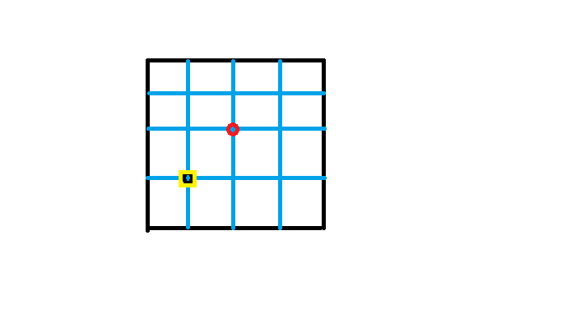

There is only one Congress constituency which can be enclosed inside a rectangle of side 0 x 0 and total area = 0 x 0 = 0. The strongest belt is shown in yellow in the above figure.

**Sample TestCase 2**

Input

3

1 1 C

1 2 C

3 4 B

Output

2

0

Explanation

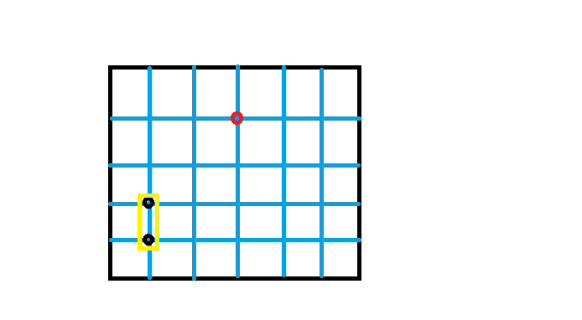

The strongest congress belt is shown in yellow in the above figure. It is a rectangle of side 1 x 0, having an area 0 and containing 2 congress won constituencies.

**Sample TestCase 3**

Input

7

1 1 C

1 3 C

3 3 C

4 1 B

4 2 B

5 1 B

5 3 B

Output

3

4

Explanation

The area shaded in yellow in the following image shows the strongest belt of Congress.

The strongest belt is a rectangle having dimensions 2 x 2. It has an area of 4 units and it is containing 3 congress won constituencies.

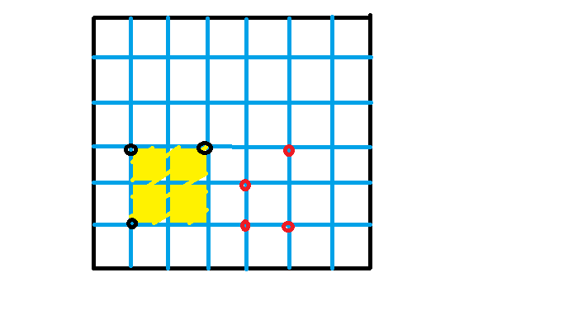

## The Hare and The Tortoise Race (100 Marks)

We all have heard the story of the hare and the tortoise. Last time the hare lost the race to the tortoise because of his laziness. Since then the hare has been requesting the tortoise for a rematch numerous times and the tortoise has been always declining his request. Just a couple of days before the tortoise has agreed for a rematch on the condition that he will decide the route of the match.



The race has to happen on the hills of the Nilgiri forest. Nilgiri forest has **N** hills numbered from **1 to N**. Some of these hills are connected by paths called forest paths. Since these paths can have sharp corners which can lead to two animals bumping into each other if they come from opposite directions, so the forest government have made them **one-way**.

You  are given the time taken by the tortoise and the hare to move along a road for every forest road. Nilgiri has total **M** forest roads which are unidirectional.

The race can start from any hill but it should also end on the same hill. In other words, the path of the race should be cyclic.

The tortoise is now thinking of the route to take which involves the minimum number of roads and the tortoise is strictly faster than the hare on this route. If there are multiple such routes, the tortoise will choose the one  which leads to the tortoise's win by the biggest margin (so that the hare doesn't dare to challenge the tortoise again in future).

*It is guaranteed that such a route always exists.*

##### Input Format

The first line contains 2 space separated integers **N** and **M** representing the number of hills and the number of forest roads.

Next follows M lines. The ith line contains 4 integers ui, vi, ti, hi - ui and vi represents the starting and ending hills of a forest road respectively, ti and hi represents the time taken to cross this road by the tortoise and the hare respectively.

##### Constraints

2 <= N <= 250

2 <= M <= N(N-1)

1 <= ui, vi <= N  (ui != vi)

0 <= ti, hi <= 1000,000,000

##### Output Format

You have to print two space separated integers - the first one is the minimum number of roads in the chosen path, and the second one is the biggest margin by which the tortoise can win the race on the chosen route.

##### Sample TestCase 1

###### Input

4 5

1 2 2 10

2 3 4 400

3 4 8 100

4 3 2 5

3 1 1 1000

###### Output

2 95

###### Explanation

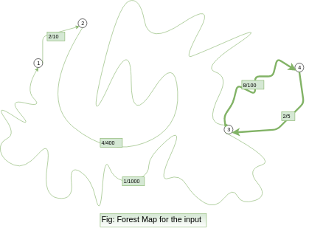

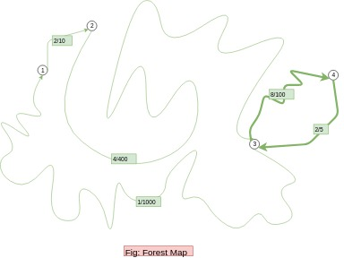

You can see, the best route is 3 ---> 4 ----> 3 which consists of 2 roads only. The margin by which the tortoise wins = (100 + 5) - (8 + 2) = 105 - 10 = 95.